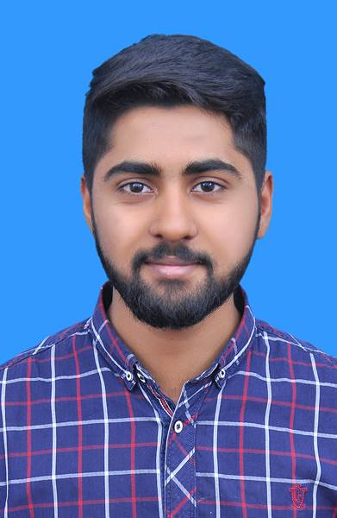
CONCINNITYS.COM

Affiliate Marketing and Management | still working
ABOUT
I Assiduous and Passionate Programmer seeking for a future leadership
program with a concentration in the optimization of design and problem
solving by implementing my technical and managerial skills to their fullest
potential.
WORK EXPERIENCE
EDUCATION
BACHELOR OF SCIENCE IN ICOMPUTER SCIENCE
COMSATS university Islamabad | 2019 - 2023

CGPA 2.68
AWARDS
Best stage performance & video making and editing

Superior
college | sept 2019

Sincere Coordinator of the badge

Superior college | sept 2019

VENTOROID SOFTWARE HOUSE
Web development | Oct 2018 - Dec 2019
Html

CSS

Web designing

Adobe photoshop
CONTACT
+923068876998
muhammadabdullahnaveed@outlook.com
https://github.com/cuimabdullah

https://www.linkedin.com/in/muhammadabdullahh/

SOCIAL
Programming
C++

(
)
Advanced
Python (Beginner)
Java Android
Web development

Html

CSS

Web designing

Enterprise Resource Planning
Extracurricular Activities
PROFESSIONAL
SKILLS
Creative spirit

Logic thinking
Reliable and professional

Organized

Time management

Team player

Fast learner

Motivated
PERSONAL SKILLS
Muhammad Abdullah
PROGRAMMER
YOUR CLOUND CAMPUS
Lecturer | Feb 16, 2021 - May 30, 2021
Programming
Python & C++
Mathematics

